

Student Name:

Current Rank: _______/54 Current GPA _________ (4.0 Scale)

Remember: This can change based

on first semester final grades! Current % ___________ (100 Scale)

Diploma Track: (REVIEW) HONORS Adv. Academic

Academic Standard

Review Name for Diploma

Student Signature _____________________ Date:_________________

**Upcoming ACT Dates**

(Westbrook School Code: 011206)

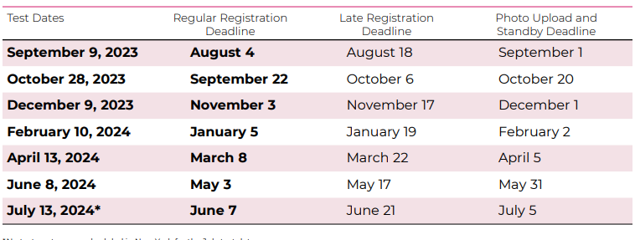

**How to send ACT scores**

*Sending scores at Registration of ACT*

1. Visit the ACT student website to begin the registration process for an ACT test. You can register online or by mail, depending upon your individual situation. If you will be registering by mail, download a registration packet to complete.
2. Utilize ACT’s college codes to designate the colleges to which you want your scores sent. Search for the colleges by location or by the college name.
3. Enter the college codes into the appropriate fields within the registration paperwork to have your scores automatically sent to these colleges after you complete the ACT test.

*Sending ACT scores after testing*

1. Visit [www.myact.org](http://www.myact.org)
2. Type in the search box “Sending your Scores”

*SUPERSCORE*

The ACT score reports will now include a superscore. An ACT superscore is the average of the four best section scores from each of the student’s ACT test attempts.

Students will need to research which colleges/universities accept the ACT superscore.

***ACT Prep Resources***

***ACT test booklet***

Mrs. Blevins can email an ACT booklet that includes test strategies and one ACT practice test. This is free.

**Sauls Tutoring and ACT Preparation**

Tutor/Teacher

Private tutoring

Facebook message through Saul’s Tutoring and ACT Preparation

**Linda Guetschoff- retired psychologist and tutor**

$50/$55/hour 256 490-3511- Cell 256-442-8975

Tutors everyday except for Tuesdays

**Kim Norton**

$150 for a 2-hour session. Her number is 256-473-1773.

**Marcia Farabee**

Private tutor for English and Reading

Sessions last anywhere from 1 to 1.5 hours. Cost starts at $25 per person, per session.

Contact Mrs. Farabee 256-295-2428

**All Pencils Down**

Allpencilsdown.net

205-989-4356

[questions@allpencilsdown.com](mailto:questions@allpencilsdown.com)

They have a multitude of learning options to choose from. They have online resources so you don’t have to drive back and forth to Birmingham.

**Princeton Review**

Princetonreview.com

Online ACT Prep Course with a money back guarantee

Private tutoring and online class instruction

**ACT.org**

ACT has FREE resources online. Follow these instructions to access resources:

1. Visit myACT.org
2. Create a student account
3. Along the task bar at the top select the drop down Test Prep- choose ACT Academy
4. Start practicing with ACT Free Online Tests

**Kaplan**

Kaplan has FREE resources online. Follow these instructions to access resources:

1. [www.kaptest.com/**ACT**](https://r.search.yahoo.com/cbclk2/dWU9OUUzNkMzNjM3OEM5NDc4NiZ1dD0xNTY3NTM2ODkxMzMzJnVvPTExNjMzMTEwMzUzJmx0PTImcz0xJmVzPWU3eVBvc01HUFMuZmUubkxlWU14MUc0aFl6cjdlTEh5VHE1SmxaVHJpcGRzZGV4YU05US0-/RV=2/RE=1567565691/RO=10/RU=https%3a%2f%2fwww.bing.com%2faclick%3fld%3de3OIOCPZ9bQM14ooiQfD_dSjVUCUypDBwkjIuFP77kvPPLHWR6oBnjn7iQIrRsUcIHwDtcfhbbJK4c52hV-tRQhdOPRR01LUO8S92MbN1nKTgEMTNKZ3a2cDWNliCyrsF0o4xia7AZKa4-VxgD91THf3ad8X8U67_19BTxPvUqTIWyN5nj%26u%%26rlid%3dcb3a6f75d7a917637304321b61520a11/RK=2/RS=eothVILJ8MOduKeuA0IpNTTqPj8-;_ylt=AwrCwLD7tm5dLEsAWiwPxQt.;_ylu=X3oDMTB2c2lzOGFwBGNvbG8DYmYxBHBvcwMxBHZ0aWQDBHNlYwNvdi10b3A-;_ylc=X3IDMgRydAMw?p=kaplan+act+prep&IG=0ac2c0b096294a25b900000000340ef2)
2. Taskbar click on More/ Free Practice

***ACT Test Information Release***

***What is it?***

This is a service from ACT that allows you to review your answers, the original test questions, and the answer key used to grade your multiple choice section. Each testing year, three Saturday test dates receive the ability to order the Test Information Release. They are usually in April, June and December.

***Fees?***

The ACT Test Information release can be purchased at the time of registration or by completing an order form from the ACT website. Receiving the information costs an additional $20.00, on top of any original ACT fees.

***Benefits?***

Release service is a great way to prepare yourself for a retake of the test. If you are stumped by your ACT score, ordering Test Information release can help you make sense of what happened.

**NCAA Athletes**

***NCAA Student Registration information for Certification Account and/or Profile page.***

**Division I Academic Requirements**

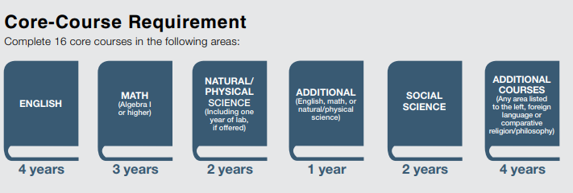

**Division II Academic Requirements**

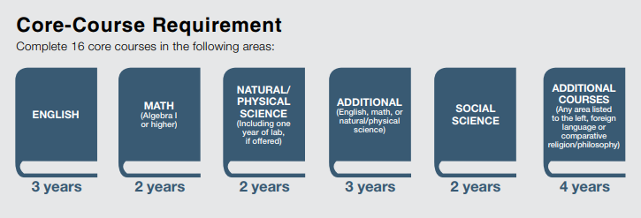

**What Do Students Need Before Taking an Official Visit?**

In order to go on an official visit, students must complete their Certification Account registration with the NCAA Eligibility Center (including submitting payment or a fee waiver request), be on that NCAA Division I or II school's Institution Request List (IRL) and present the institution with a high school or college academic transcript. If a student currently has a Profile Page, he/she must convert that account to a Certification and pay the fee/request a fee waiver. Students will need to refer to the NCAA Recruiting calendar that defines certain periods during the year in which recruiting may or may not occur in a particular sport. To view your division- and sport-specific recruiting calendar visit on.ncaa.com/RecruitCal.

**NCAA Registration Process**

The ninth grade is a great time for students to start the initial-eligibility process by registering with the Eligibility Center. The Eligibility Center recommends ninth grade student-athletes register with a free Profile Page at [eligibilitycenter.org](http://click.mail2.ncaa.com/?qs=5b33dc2a9bcea9157bcff143828d5e58dd98bf64de92f5fe0e1d53930f146681a82faf7ca4aef8dce43f973e80fd23de18351998d2ff24b3d46f486b526177b5). Students should expect to spend 15 to 30 minutes to complete a Profile Page. If at any time the student wishes to play at the Division I or II level, they can transition to a Certification Account and pay the registration fee to begin the certification process.

**Career Direct Assessment**

Career Direct is a unique online assessment designed to help you maximize your God-given talents and abilities. The Career Direct assessment can help you conquer the pressure of finding out what you want to do with your life by helping you better know yourself!

$85.00/student includes the assessment and two-hour coaching session.

**Virtual Job Shadow**

Each student has access to an online Career and College readiness resource. Log on to have access to personality and work interest assessments that will lead students to different career options to consider. Then, find out the best way to pursue that career through vocational training, a College or University. Other resources such as a resume builder and a planner for short term and long term goals are available as well!

Visit virtualjobshadow.com

Login

Students Username- school email address

Students Password- School password

**Free Application Federal Student Aid**

***FAFSA Application Opens December 1***

<https://fafsa.ed.gov/>

You will be applying for the 2024-2025 school year since that is when students will be applying for financial aid. Just for planning purposes, you will use tax information from 2022. Once in college, students will need to continue to fill out a FAFSA every school year.

**TRANSCRIPTS**

Set up a Parchment account so you can

Transcript Requests ASAP. **All** Transcript requests will be sent through Parchment.

1. Parchment.com
2. Create an account
3. Select Learner or Parent

**INTERNSHIPS**

1. Internship Agreement
2. Internship Attendance Log
3. Internship Summary Report
4. Evaluation report for WCS Intern

**REMIND**

*Enter this number*

81010

*Text this message*

@gowcs2024

**Dual Enrollment**

1. Universities/Colleges will require an official transcript to be sent from the University/College where the dual enrollment class was taken.
2. If the dual enrollment class was taken at GSCC, GSCC will require your WCS graduation transcript to be sent from your WCS parchment account to GSCC before they will release the GSCC transcript to another University/College.
   1. Once you send your WCS graduation transcript to GSCC, you will then need to go to <https://www.gadsdenstate.edu/admissions-aid/transcripts.cms> to request that your GSCC dual enrollment transcript be sent to your University/College.
   2. I will notify you via REMIND when your graduation transcript is ready.
   3. You will be able to send transcripts for FREE through approximately June 1st , after that you will have to pay around $5.00 for each transcript sent.
3. Each University/College should have a *Course Equivalency Transfer Table* that will explain how dual enrollment credits transfer into their school.

**Common Applications**

Check with Common Application to see if the College/University accepts the common application. Visit commonapp.org

**Preparation for College Applications**

1. Ask two teachers/counselors to write letters of recommendation for college. Provide each teacher/counselor with a resume and/or Senior brag sheet.
2. Complete Resume and Cover Letter
3. Check with your perspective college to see if they require an admission essay
4. Make sure your perspective colleges have your ACT/SAT scores.
5. Review all perspective school’s college application deadlines.
6. Last week of October the State of Alabama does a Free College Application week. Look for more information regarding this.

**Scholarships**

Please send a list of your scholarship offers to [hblevins@westbrookchristian.org](mailto:hblevins@westbrookchristian.org). Include name of scholarship, amount offered, college/university/organization offering, and if you plan to accept. Students will be recognized on Honors Day for all scholarship offers.

**Continue to watch the Counselor REMIND for the most up to date Scholarship Information

**Contact Mrs. Blevins for a list of scholarships where students can begin their search.

*Best Scholarship Search Platforms*

Fastweb.com

Cappex.com

Unigo.com

Bigfuture.collegeboard.org

CollegeGreenLight.com

SallieMae.com

*Local/State Scholarship Information*

1. Contact state or local agencies: Nearly every state offers scholarships that are specifically intended for residents. Many times they're limited to those attending public colleges or universities, or they're open to students interested in careers in public service or government.

***Visit Community Foundation of Northeast Alabama

*** Visit [CollegeScholarships.org](http://www.collegescholarships.org/scholarships/states.htm) to search for scholarships specific to your Alabama.

1. Use the old-fashioned way of contacting businesses or organizations: call them up! Start by contacting the larger businesses in your area and asking them if they have a scholarship program that is open to area high school students. This information may also be on their websites, so you may want to check there first.

**AP CLASSES**

I will be taking the AP Calculus Exam? ________________

I will not be taking the AP Calculus Exam? _____________

I will be taking the AP English Exam? ________________

I will not be taking the AP English Exam?________________

$89.00 per exam is due by November 15th __________

**Reminder that Mrs. Croyle offers a prep class during Enrichment in the Spring to help you prepare for the AP Calculus Exam.

**CLEP options**

The College Level Examination Program (CLEP) tests allow you to earn college credit by taking exams instead of taking classes.

Jacksonville State University administers the CLEP tests. Students should register through College Board to take the CLEP test before scheduling an appointment with Testing at JSU. To register and pay the exam fee to CLEP visit <https://clep.collegeboard.org/>

**Alabama FAME Education Program**

* Fame is an “Earn While You Learn” apprenticeship style program through Gadsden State Community College.
* Once the student has graduated from high school, they will attend school 2 days a week and work 3 days a week in an Advanced Manufacturing Facility. (Honda, Koch Foods, Prince Metal Stampings, General Dynamics and more).
* Students are guaranteed to start at $12.00/hour and work at least 24 hours/week.
* MOST students qualify for Financial Aid, Grants, AND WIOA or ALAMAP scholarships (FREE SCHOOL)
* After 2 years in the program students receive an Associate in Applied Science degree in Industrial Automation, FAME Advanced Manufacturing Technician credential and 5 Lean Manufacturing Certifications! All from Gadsden State Community College.
* APPLY to be a student at Gadsden State Community College: [www.gadsdenstate.edu](http://www.gadsdenstate.edu)
* PLUS- Complete the FAME application at [www.gadsdenstate.edu/fame](http://www.gadsdenstate.edu/fame)
* See Mrs. Blevins for more information.

**HERFF JONES**

**SENIOR INFORMATION**

* In September Herff Jones representative will be here to give information to students regarding cap, gown and other graduation items.
* The Herff Jones representative will come back to collect orders for cap, gown and other graduation items.
* Cap and Gowns are rental items and will be returned after graduation. The rental cost for the cap and gown is $81.75 and is due February 1st.

Student Name

Address, City, ST ZIP Code | Telephone | Email

**Objective**

Check out the quick tips below to help you get started. To replace tip text with your own, just tap it and start typing.

**Education**

***High School Diploma* | Westbrook christian school| expected may 2018**

G.P.A.

Rank

**Honors and Achievements**

Achieved Honor Roll (2015-2016)

**School Involvement and Leadership**

Member of the Key Club (2016-2018)

Varsity Track Team (2016-2018)

SGA President (2017)

**Employment**

**Job Title | Company | Dates From - To**

This is the place for a brief summary of your key responsibilities and most stellar accomplishments.

**Community Service**

Contributed more than 150 volunteer hours to DeLand Museum Art Summer Camp

Collected food or (1200 pounds of food) for the Etowah County Foodbank